Copyright © 2020 by Abu Dhabi Government Procurement Office. All rights reserved. 1

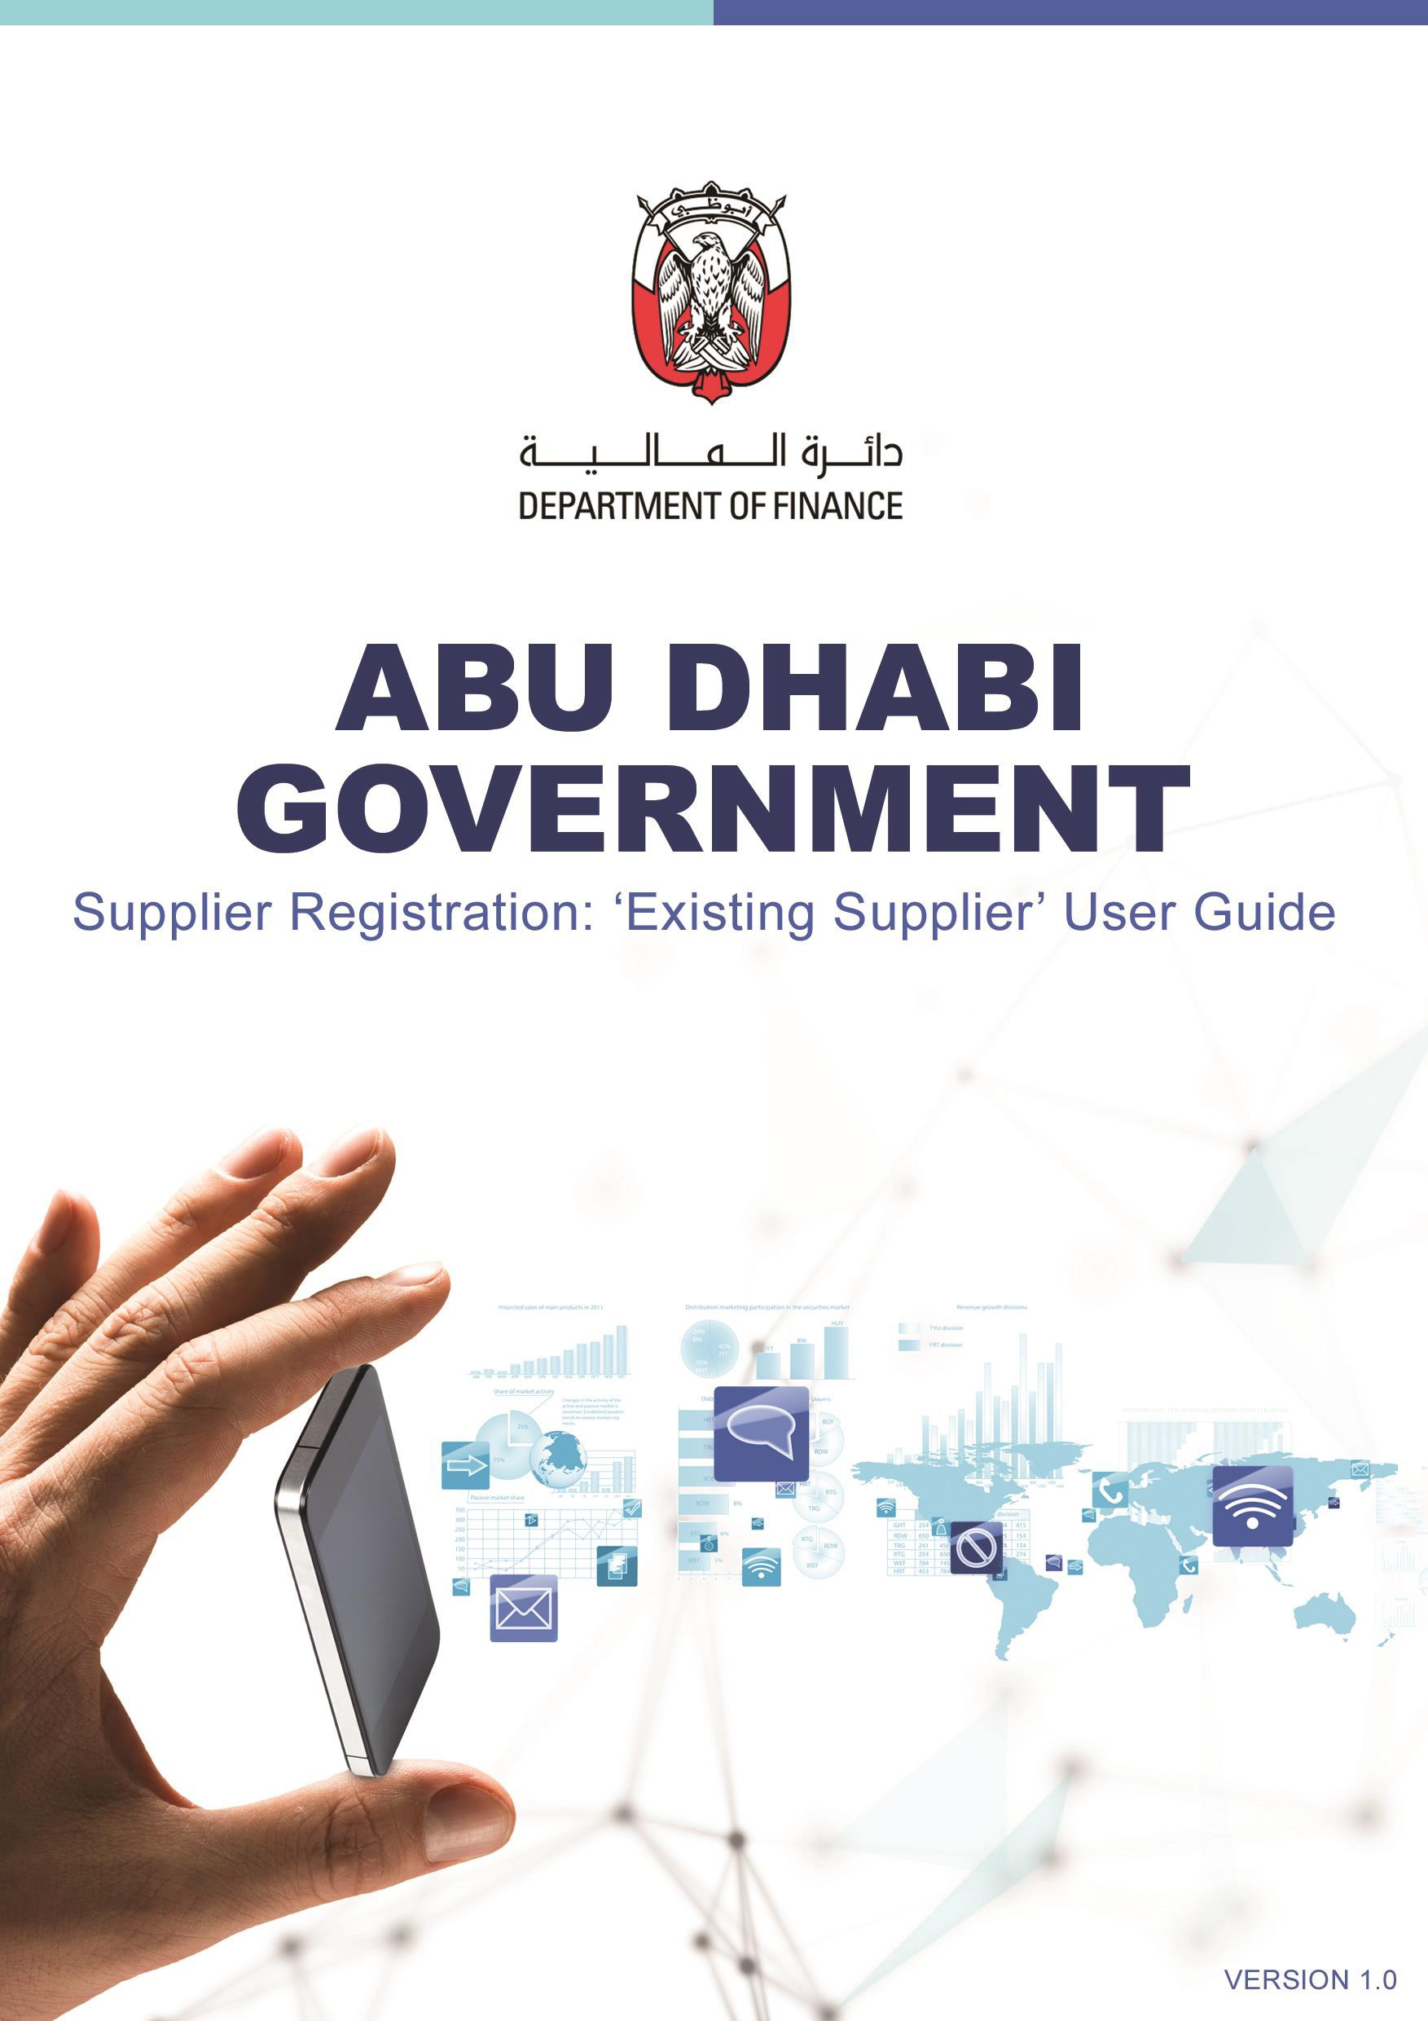

**ГОСУДАРСТВЕННЫЕ ЗАКУПКИ АБУ-ДАБИ**

**РУКОВОДСТВО ПО РЕГИСТРАЦИИ ПОСТАВЩИКОВ ДЛЯ ПОСТАВЩИКОВ, НЕ ИМЕЮЩИХ ЛИЦЕНЗИИ DED В АБУ-ДАБИ**

#### VERSION 4.7

**TABLE OF CONTENTS**

Purpose 3

Supplier Classification 3

Process Overview for Suppliers with NON-Abu Dhabi DED License 3

Supplier Registration Statuses 3

Supplier Qualification Statuses 4

1. Steps on How To Register To SAP Ariba 4

STEP 1. Supplier Request 4

STEP 2. Supplier Registration 5

STEP 2.1. Create an Ariba Network account 5

STEP 2.2. Respond to the Registration Questionnaires 9

STEP 2.2.1. Respond to General Supplier Registration Questionnaire 9

STEP 2.2.2. Respond to Payment and Bank Questionnaire 15

STEP 3. Supplier Qualification 20

STEP 3.1. Respond to the Supplier Qualification 20

1. Revise/Update Supplier Questionnaire Responses 23
2. Providing additional information to GPO Supplier Registration team 26
3. Required Documents to Complete Supplier Request and Supplier Registration 28

Suppliers with Non-Abu Dhabi DED License 28

* 1. Supplier Request 28
  2. Supplier Registration 28

1. SAP Ariba Help Center – How to Raise a Ticket to SAP Ariba Network Support 29
2. Frequently Asked Questions (FAQs) 33

CONTACT US 35

**Цель**

Этот документ представляет собой руководство пользователя, позволяющее Поставщикам, не имеющим лицензии Департамента экономического развития Абу-Даби, завершить регистрацию в Департаменте государственной поддержки через SAP Ariba.

Регистрация поставщика выполняется с использованием модуля управления жизненным циклом и производительностью поставщиков SAP Ariba и сети SAP Ariba. Поставщики должны следовать процессу, описанному в этом документе, для регистрации в системе SAP Ariba.

# КЛАССИФИКАЦИЯ ПОСТАВЩИКОВ

Поставщики классифицируются в соответствии с их лицензией:

((1) Поставщики из Департамента экономического развития Абу-Даби (ДОБАВЛЕНЫ) Лицензия

(2) Поставщики, не являющиеся сотрудниками Департамента экономического развития Абу-Даби (Не ДОБАВЛЕННЫЕ) Лицензия

**ОБЗОР ПРОЦЕССА ДЛЯ ПОСТАВЩИКОВ, НЕ ИМЕЮЩИХ ЛИЦЕНЗИИ DED В АБУ-ДАБИ**

Если у компании нет действующей лицензии DED Абу-Даби, поставщики должны следовать описанному ниже процессу.

Процесс состоит из 6 этапов, как показано ниже.



**Запрос поставщика**

**Регистрация поставщика**

**Квалификация поставщика**

**Request**

**Submitted**

**Request**

**Approved**

**Registration**

**Submitted**

**Registration**

**Approved**

**Qualification**

**Submitted**

**Qualification**

**Approved**

**Supplier Status**

**Invited**

**Registered**

**Qualified**

*Abu Dhabi Government Entity User*

*Supplier*

*Supplier Registration Team, Government Procurement Office, Department of Government Support*

**СТАТУСЫ РЕГИСТРАЦИИ ПОСТАВЩИКОВ**

|  |  |
| --- | --- |
| **Invited** | The supplier has been invited to register. |
| **In Registration** | The supplier has started the registration but in progress for completing the Registration Questionnaires. |
| **Pending Approval** | The supplier has submitted the Registration Questionnaires for approval. |
| **Pending Resubmit** | The approver has asked the supplier for more information as a condition of approving the registration. |
|  |  |

|  |  |
| --- | --- |
| **Registration Denied** | The supplier’s registration has been denied |
| **Registered** | The supplier registration has been approved. |

# SUPPLIER QUALIFICATION STATUSES

|  |  |
| --- | --- |
| **Qualification not started** | The supplier has been registered, but no qualification has been initiated. |
| **Qualification Started** | The qualification process has been initiated. |
| **In Qualification** | The supplier has started filling out the qualification questionnaire but has not yet submitted. |
| **Pending Qualification Approval** | The supplier has submitted the responses to the qualification questionnaire and it is in the approval process. |
| **Qualification Rejected** | The supplier's qualification has been rejected. |
| **Qualified** | The supplier's qualification has been approved. |
| **Qualified for Some** | The supplier has multiple qualifications with different commodity, region or department. |
| **Pending Resubmission** | The approver has asked the supplier for more information as a condition of approving the qualification. |
| **Qualification Expired** | The supplier’s qualification has been expired. |

**A. ШАГИ ПО РЕГИСТРАЦИИ В SAP ARIBA**

**STEP 1. Запрос поставщика**

Связаться с пользователем Правительственного учреждения Абу-Даби (ADGE)

Вам необходимо запросить государственное учреждение Абу-Даби (MADGE), с которым работает поставщик, для предоставления товаров/ услуг, чтобы создать Запрос поставщика от вашего имени в SAP Ariba.

Как только вы получите уведомление по электронной почте о том, что ваша Форма запроса поставщика одобрена Группой регистрации поставщиков Управления государственных закупок (GPO), вы можете выполнить действия по регистрации поставщика.

**STEP 2. Регистрация поставщика**

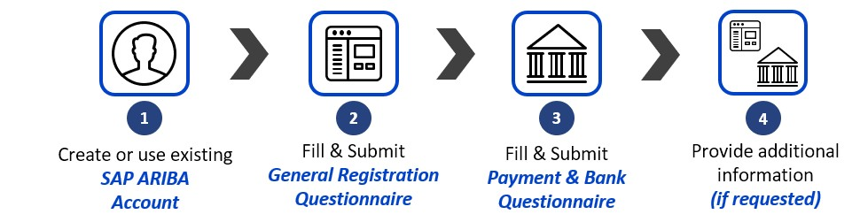

**ШАГ 2.1. Создайте учетную запись Ariba Network**

Как только Запрос Поставщика, отправленный Пользователем Правительственного учреждения Абу-Даби (ADGE) от вашего имени, будет одобрен, вы получите электронное письмо с темой “Приглашение: Зарегистрируйтесь, чтобы стать поставщиком в Департаменте государственной поддержки” на адрес электронной почты, указанный в разделе "Контактное лицо", с приглашением продолжить регистрацию в SAP Сетевой портал Ariba.

* 1. Once the email notification is received, follow the **“**Click Here**”** link.

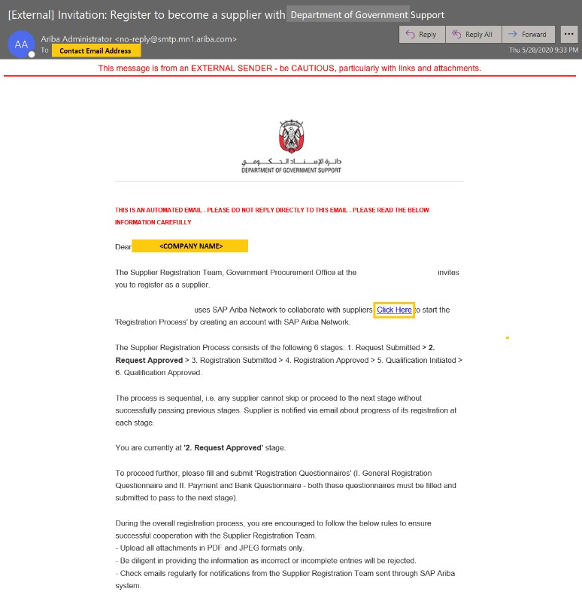

**1**

#### Please do not reply to the auto-generated emails. Replies to this email is not received by the Department of Government Support.

* 1. Click **“Sign up”** to create an account or Login if supplier already have an existing account.

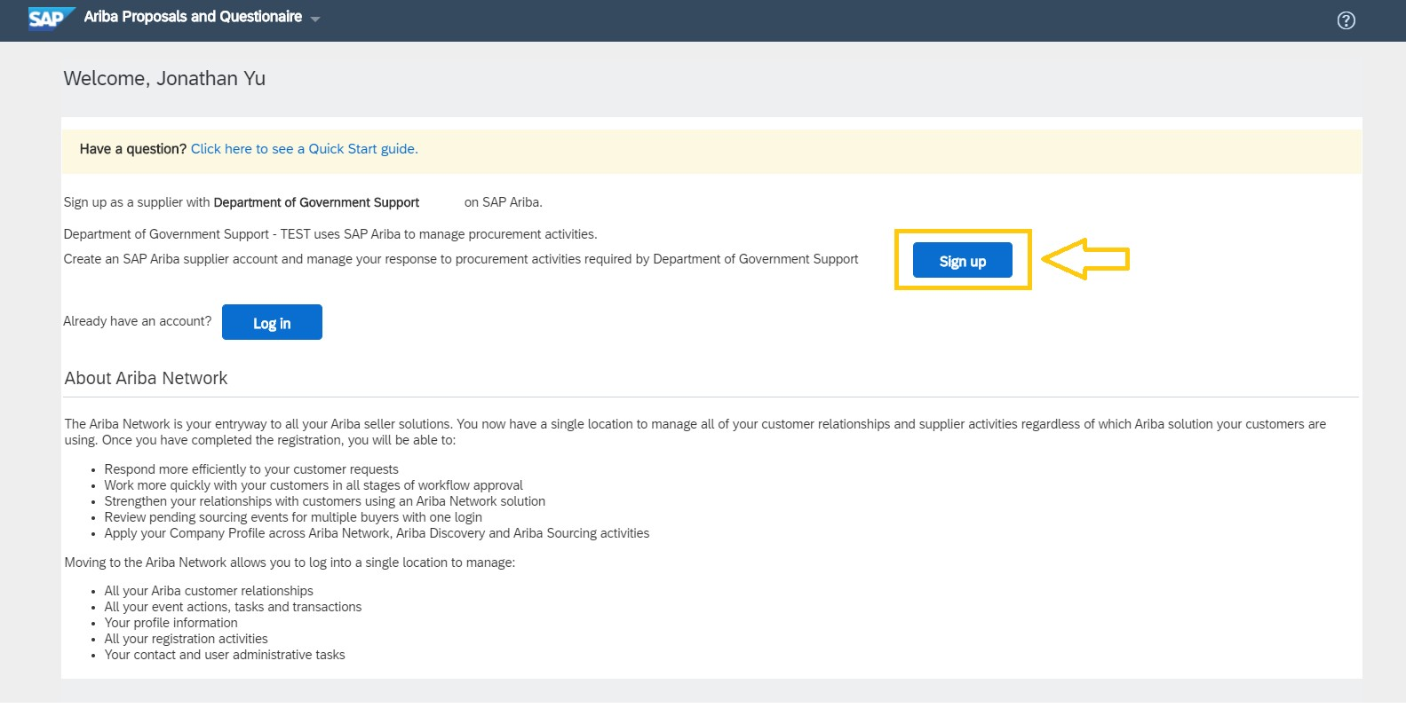

**2**

There are two sections in this page – **Company information** and **User account information**. The **Company information** contains the Company Name and Address. Company Name is pre-populated with the information from the Supplier Request form.

#### Company information

* 1. Update the Country, Address, City, State and Zip Code.

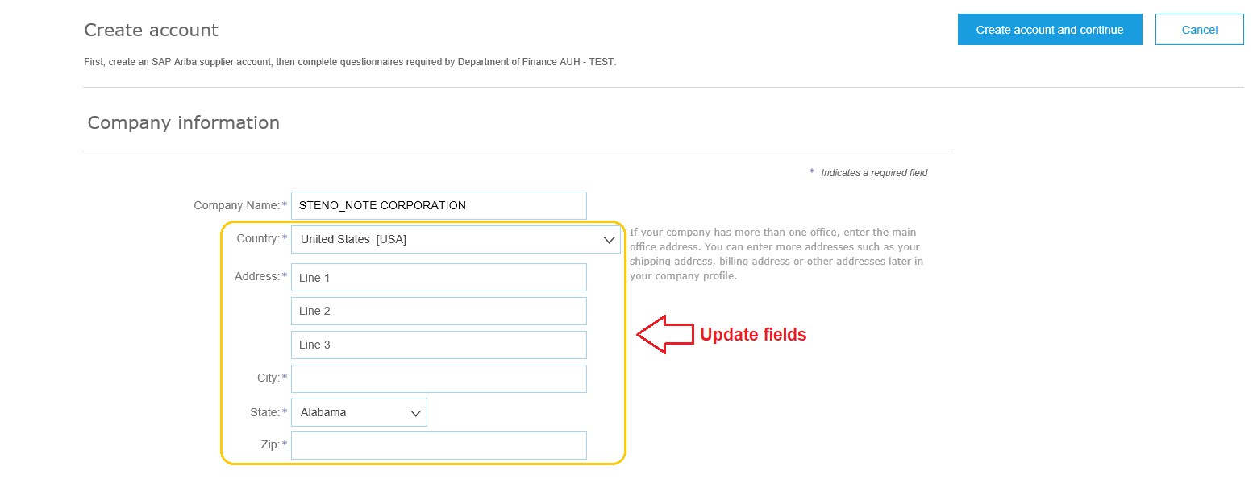

**3**

#### User account information

* 1. Input the SAP Ariba Network credentials in the user account information section.

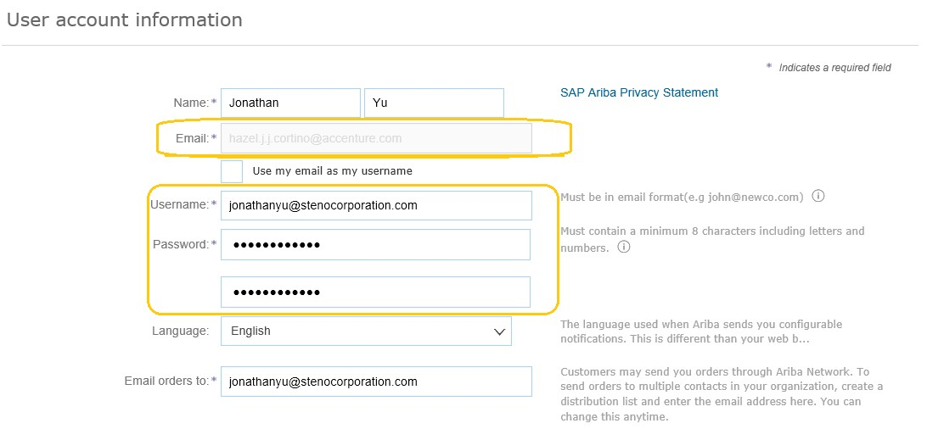

**4**

#### Reminders:

* + - Please take note of the Username and Password as this is your credentials to log into SAP Ariba Network Supplier Portal. The default username that you will see is the Contact Email Address provided in the Supplier Self-Request Form.
    - Email and Username are different fields and updating the Username to a new email will not update the email address of the account owner. You may update the email once account is created. For instructions, please check FAQ section.
    - Product and Service Categories and Ship-to or Service Location details in the “Tell us more about your business” section is required.
    - Read and acknowledge the Terms & Conditions and Privacy Statement of SAP Ariba.
  1. Populate Product and Service Categories and Ship-to or Service Locations.
  2. Read and Agree to the Terms & Conditions of SAP Ariba by clicking on the check box.

#### Click “Create account and continue”.

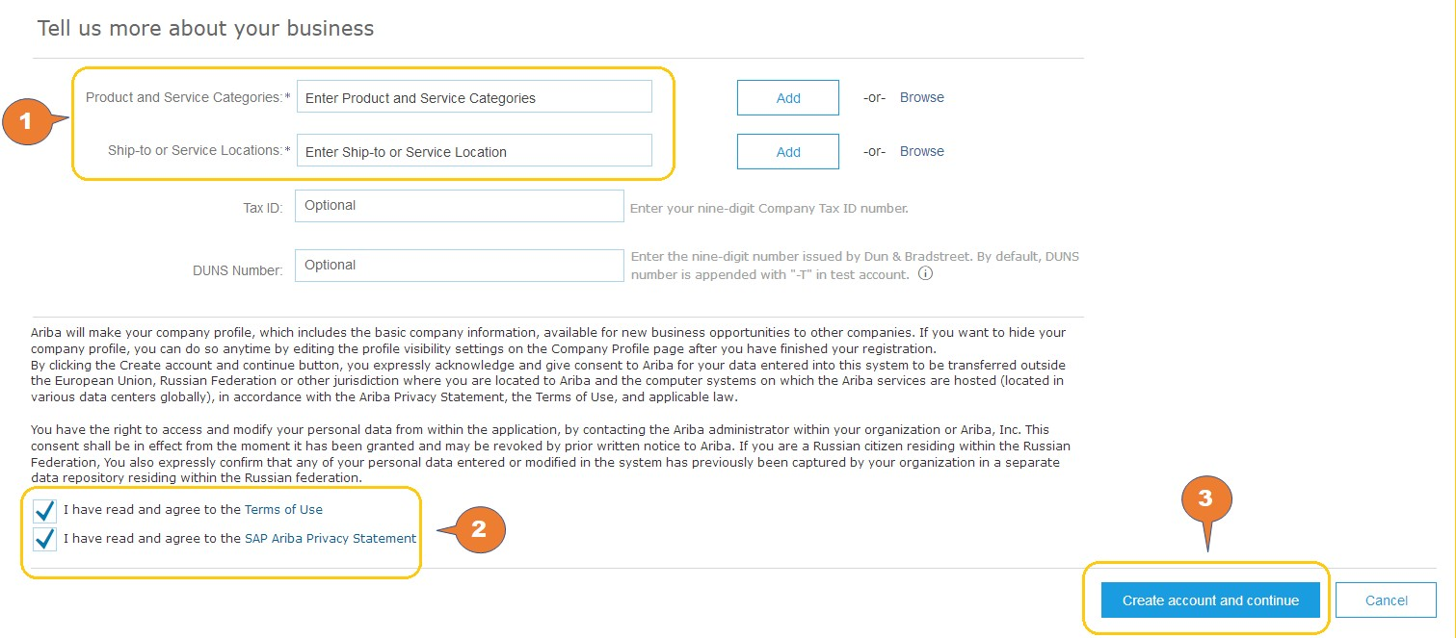

**5**

**6**

**7**

Once the account is created, you will receive an auto-generated email from Ariba Commerce Cloud with subject “**Welcome to the Ariba Commerce Cloud**” containing your SAP Ariba Network ID and username.

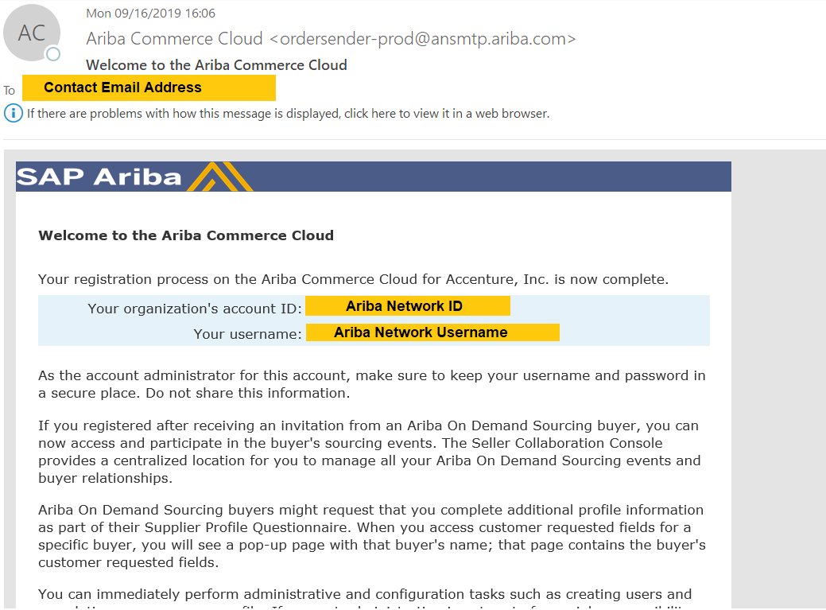

## STEP 2.2. Respond to the Registration Questionnaires

Following Ariba Network account creation, you are required to complete two Supplier Registration Questionnaires (“**General Supplier Registration Questionnaire**” and “**Payment and Bank Questionnaire**”), providing all required details and documents.

### STEP 2.2.1. Respond to General Supplier Registration Questionnaire

1. Click on the General Registration Questionnaire.

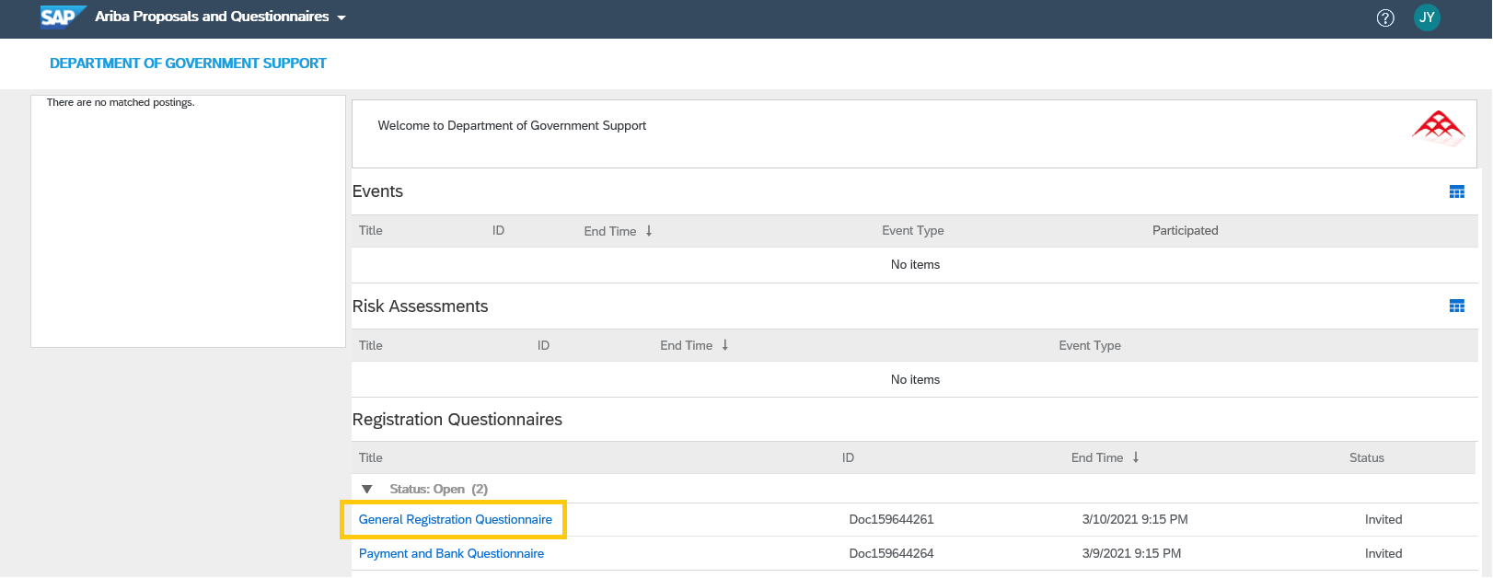

**1**

You are then redirected to the **General Registration Questionnaire** page.

1. Fill out all required questions.

**Note**: Click on the section name located at the left section of the page to fill out the form by section.

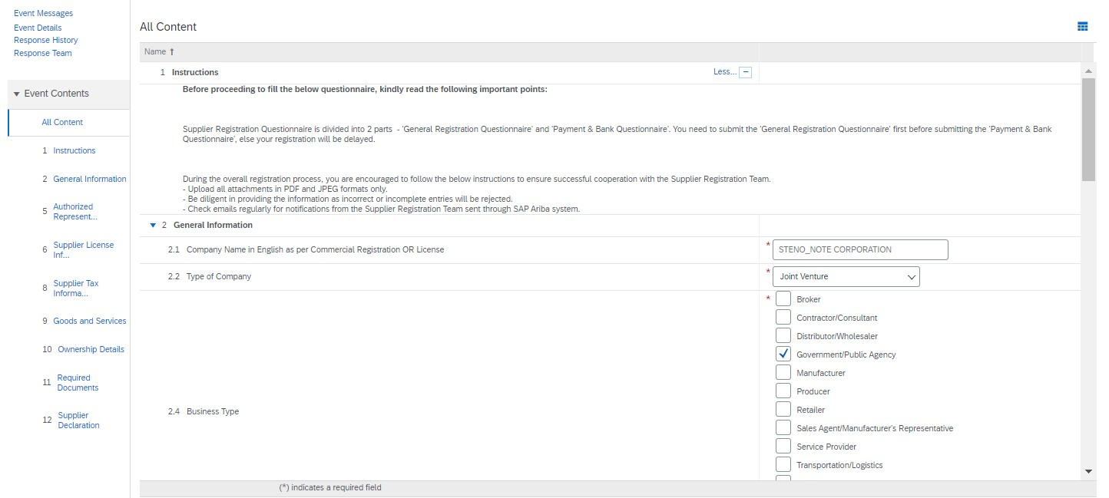

**2**

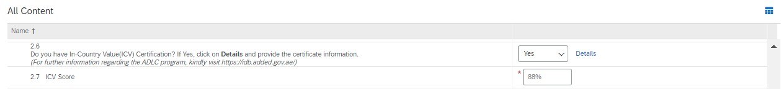

To add **Certificate** details on Question 3.6, please follow the steps below:

1. Click on **Details** beside the dropdown on question # 2.6.



1. Populate the required Certificate fields.
2. Click **OK** once complete.

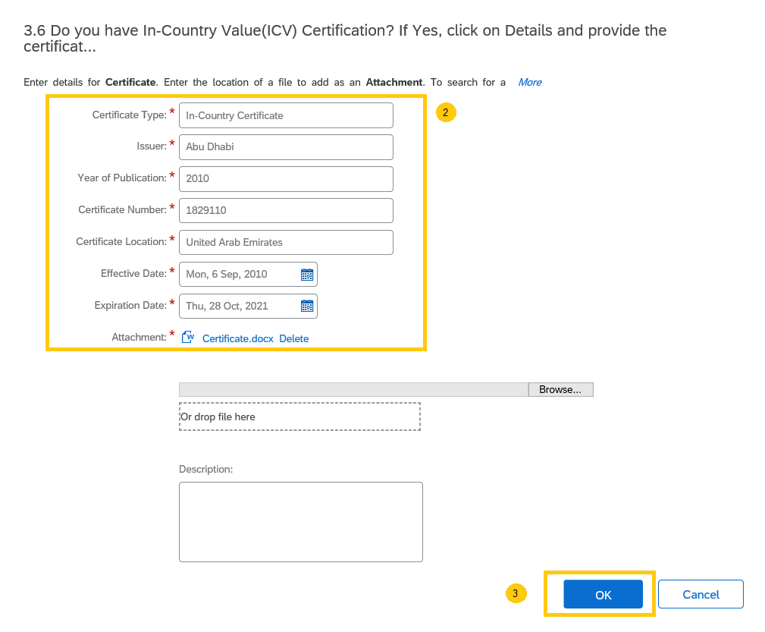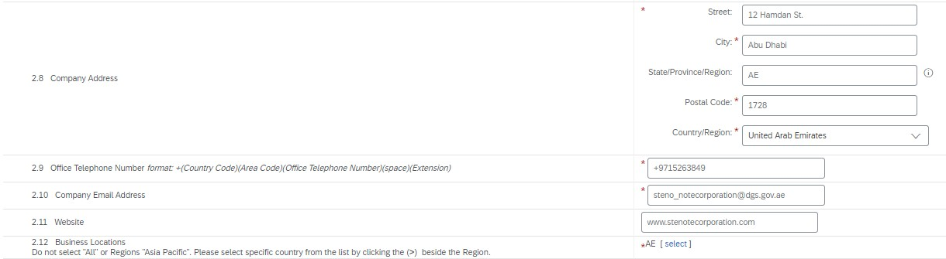

To select country from **Business Locations**, please follow the step below:

* 1. Click **Select** beside the Business Locations



* 1. Click **>** beside the region to expand the list.

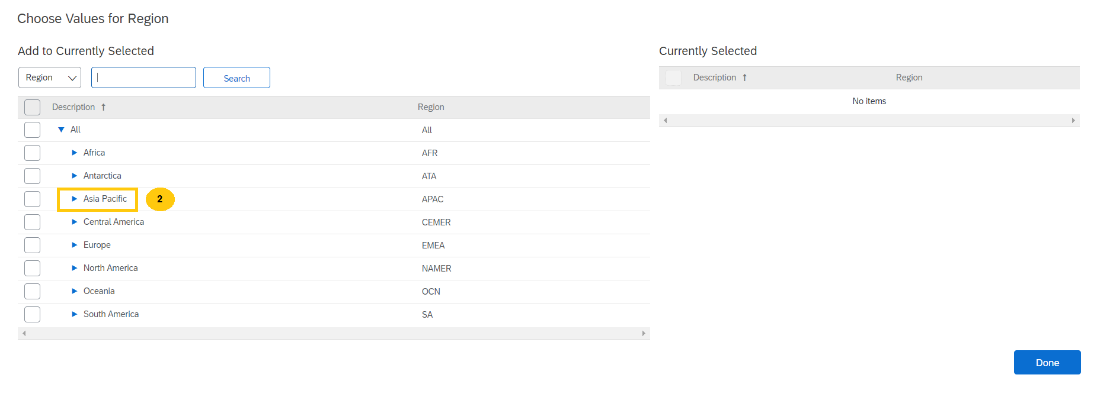

* 1. Select the country from the list.
  2. Click **Done**.

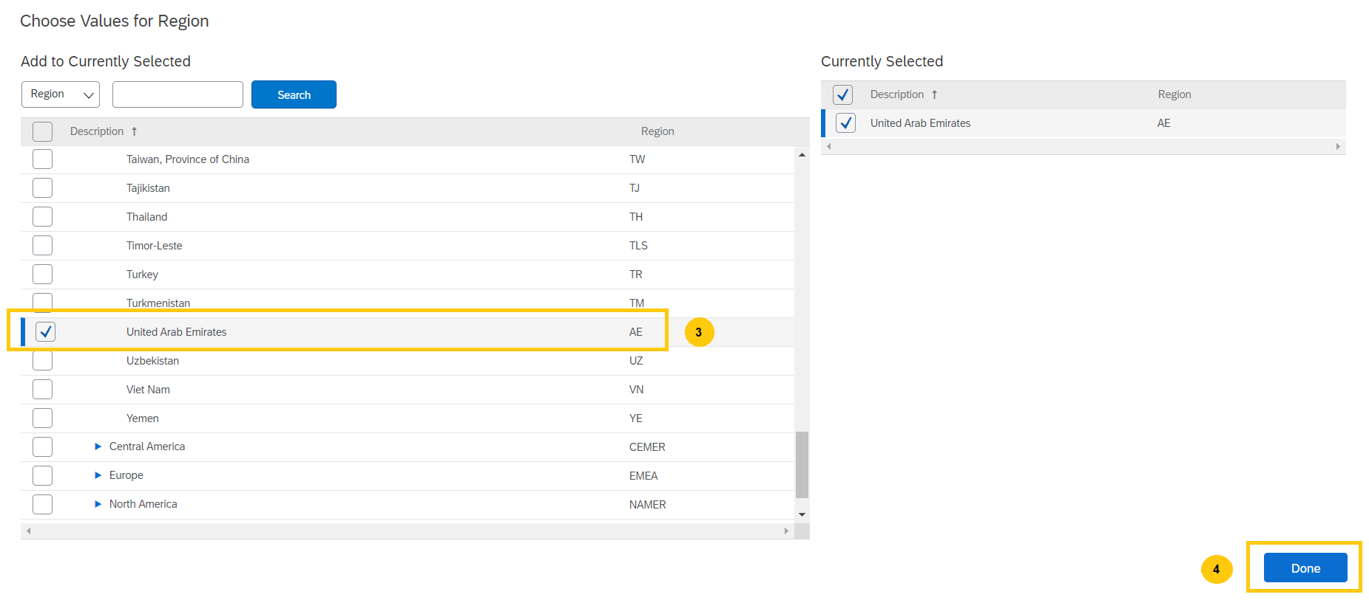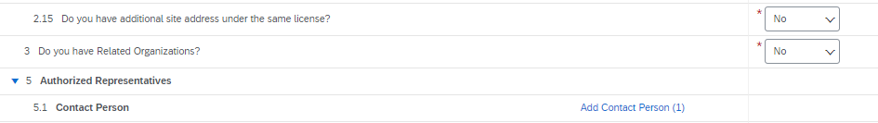

To add multiple contact person, please follow the step below.

1. Click on **Add an additional Contact Person**.
2. Once done, click on **Save**.

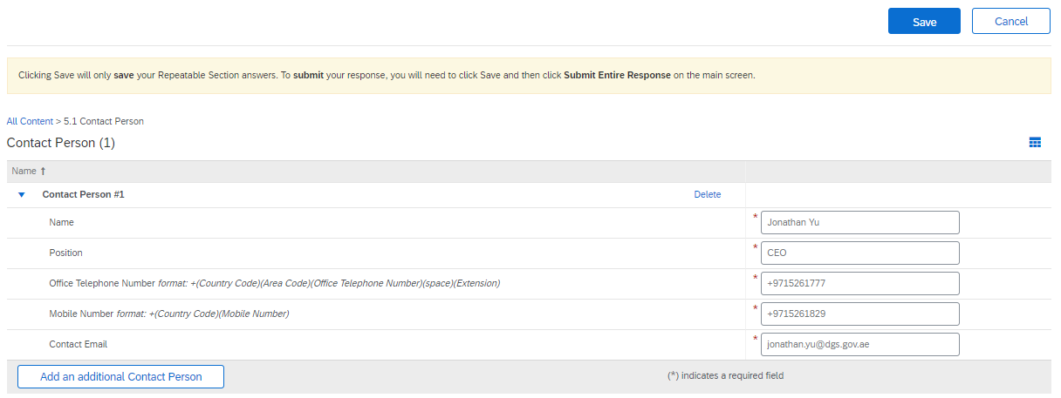

|  |  |  |  |  |
| --- | --- | --- | --- | --- |
| 2 | | |  |  |
|  | | | | |
|  |  | 1 | | |

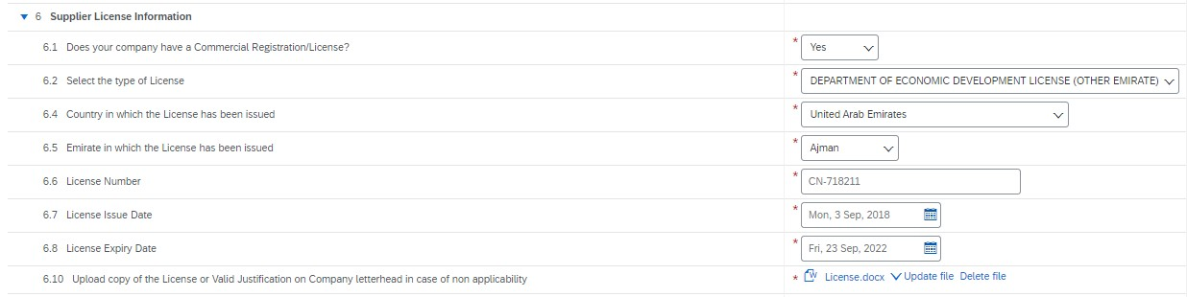

Please click on the ‘**Reference**’ in question 9.1 to download and view the list of all available Goods & Services to select from.

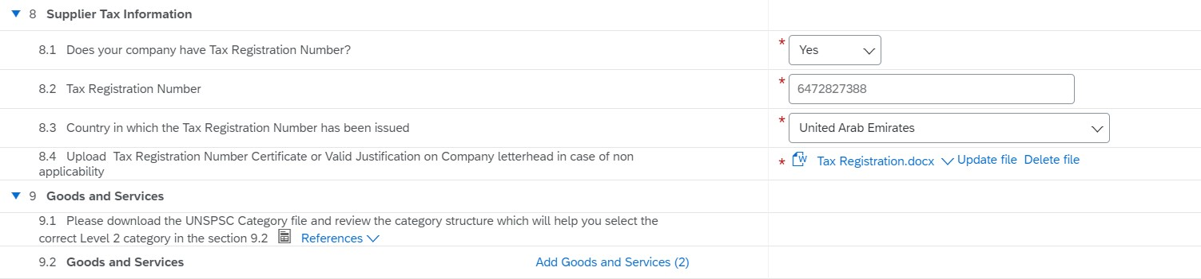

In 9.2, select the identified Goods & Services. You can select multiple Goods & Services by clicking on

‘**Add Goods and Services**’ button.



1. Inside **Goods and Services** section, click on **Add an additional Goods and Services**.
2. Once done, click on **Save**.

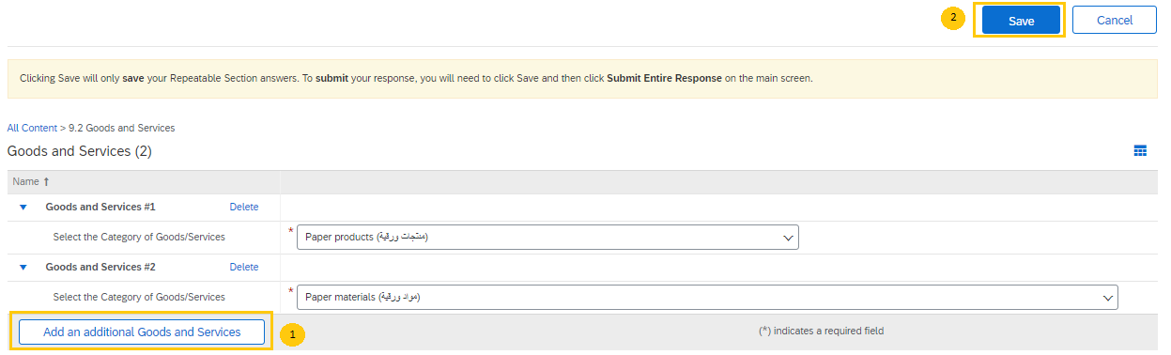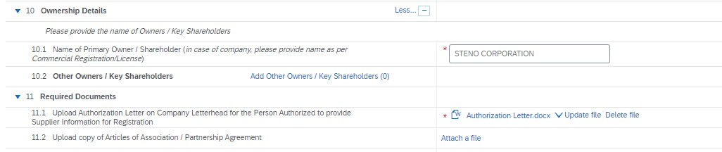

Please click on the **‘Reference’** in question 12.1 to download and review the Supplier Declaration.

#### Please read the Supplier Declaration carefully.

1. Click on **Submit Entire Response** button once completed.

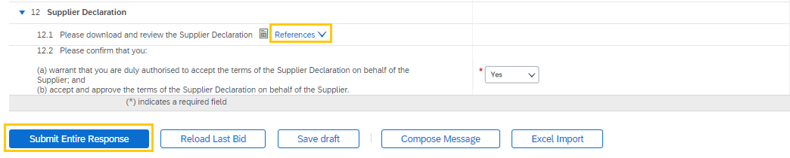

**3**

1. Click on **OK** from the pop-up window to submit your response.

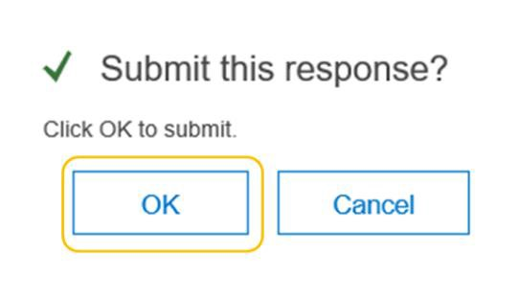

**4**

**Note**: System allows ‘saving’ the questionnaire. It is a good practice to save the questionnaire

periodically when adding the details.

In case that you have been logged out from Ariba Supplier Network, please visit the below link. [https://supplier.ariba.com](https://supplier.ariba.com/)

1. Click on the dropdown picklist from **Ariba Network** menu.

#### Click Ariba Proposals and Questionnaires.

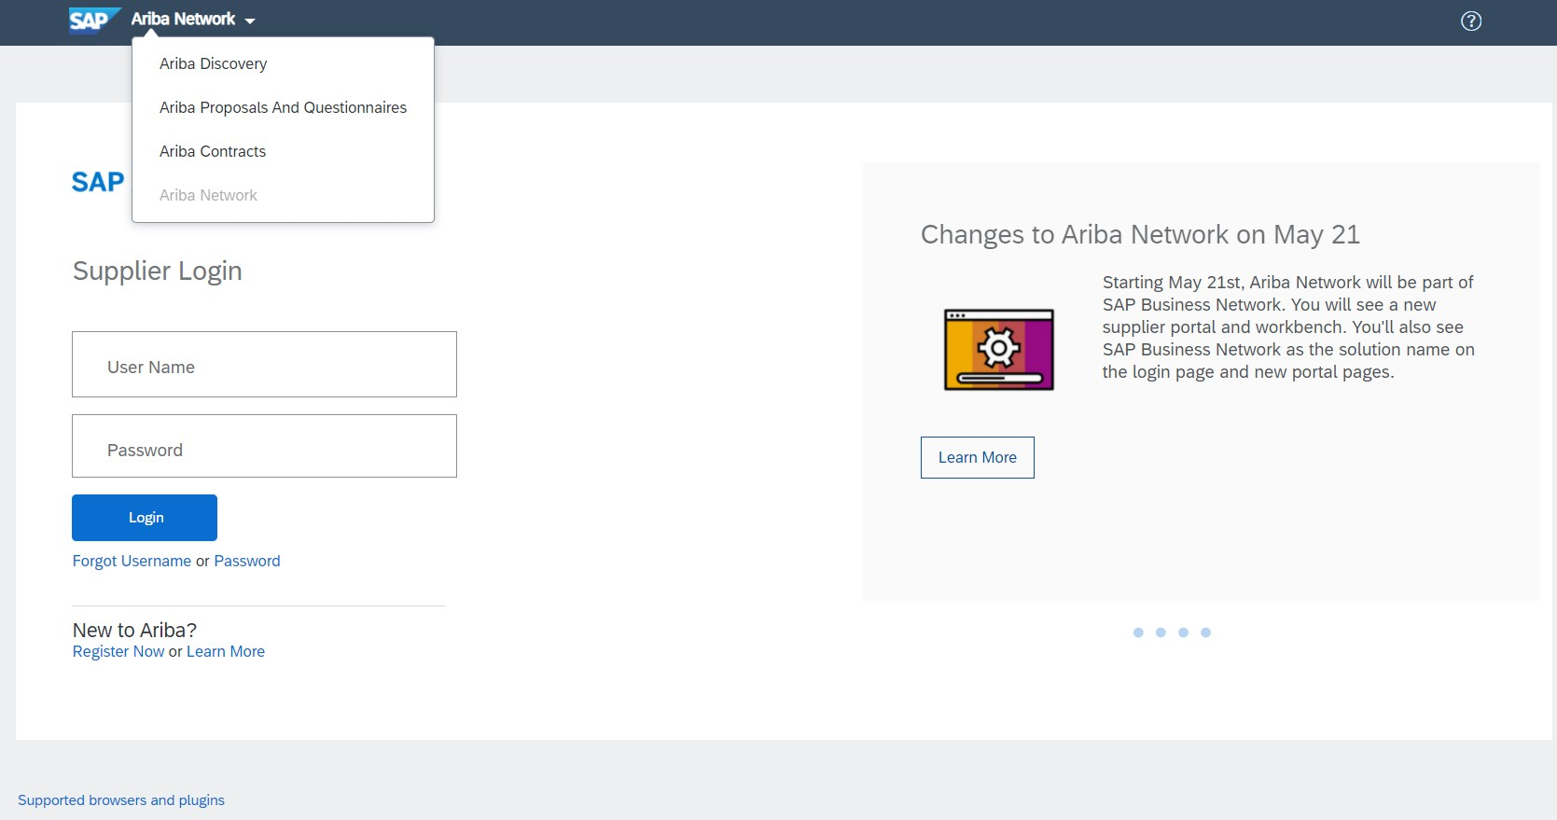

|  |  |  |
| --- | --- | --- |
|  |  | **1** |
| **2** | | |

‘

1. Input supplier credentials then click **Login**.

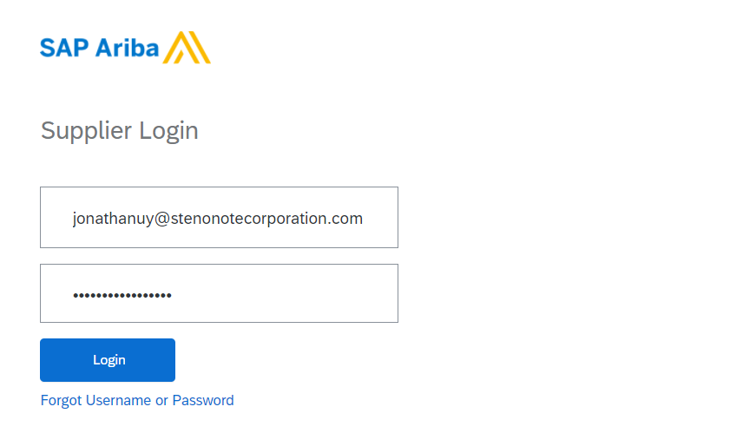

**3**

### STEP 2.2.2. Respond to Payment and Bank Questionnaire

Following submission of “**General Supplier Registration Questionnaire**”, supplier has to provide the

complete “**Payment and Bank Questionnaire**”.

**NOTE: Payment and Bank Questionnaire should be filled only after completion of General Supplier Registration Questionnaire else, your registration request gets delayed.**

An error message will be displayed in Payment and Bank Questionnaire as shown below if the General Registration Questionnaire is not yet submitted.

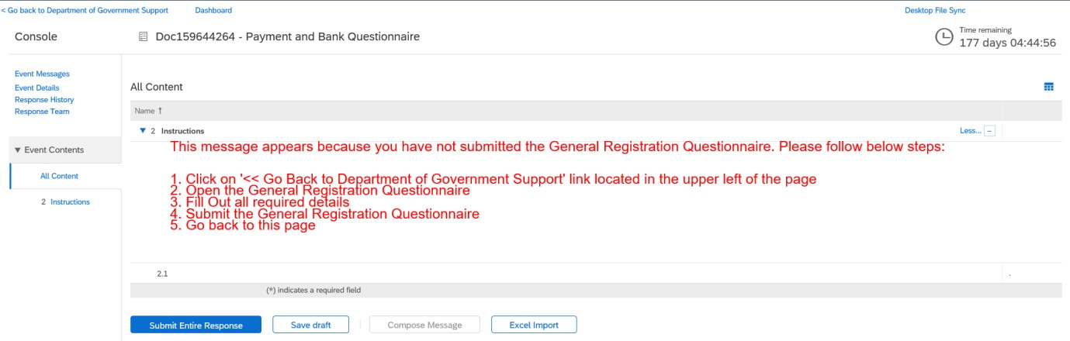

* 1. Fill out all required questions.

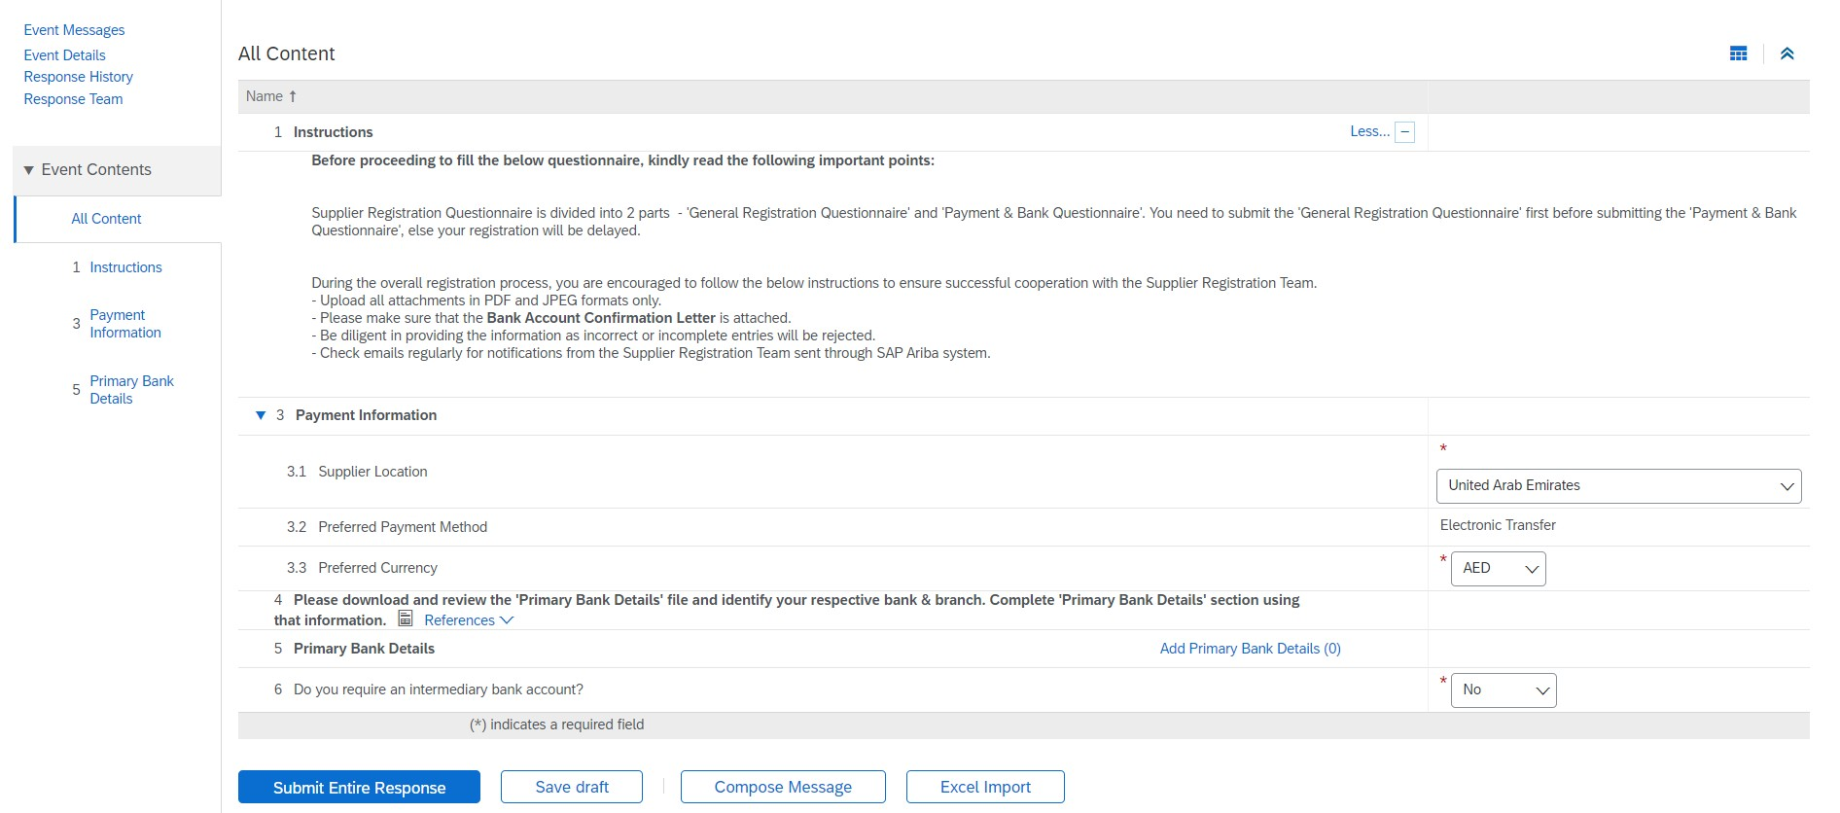

**1**

* 1. Please click on the **‘Reference’** in question #4 to download and view the guide on filling out the Primary Bank Details.
  2. Click on **Add Primary Bank Details**.



**2**

**3**

* 1. You can select multiple Bank Accounts by clicking on ‘**Add an additional Primary Bank Account**’ button.

1. Click on **Save** once done.

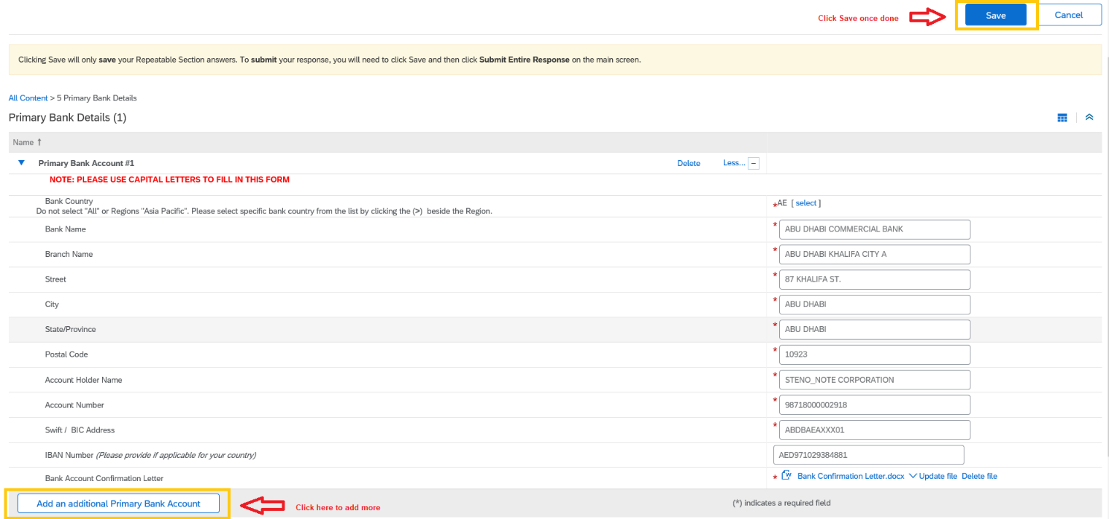

**5**

**4**

To add **Bank Country**, please follow the steps below:

* 1. Click **Select** beside the Bank Country



* 1. Click **>** beside the region to expand the list.

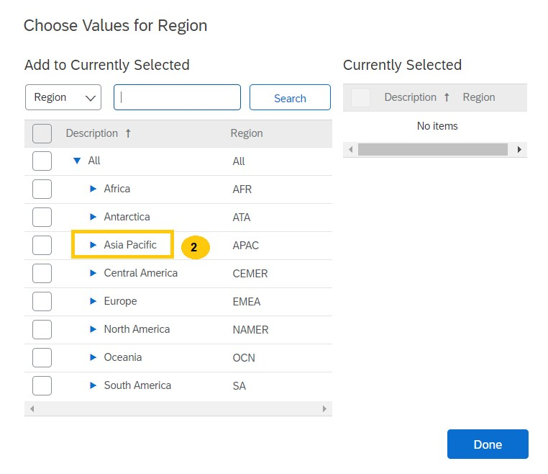

* 1. Select the country from the list.
  2. Click **Done**.

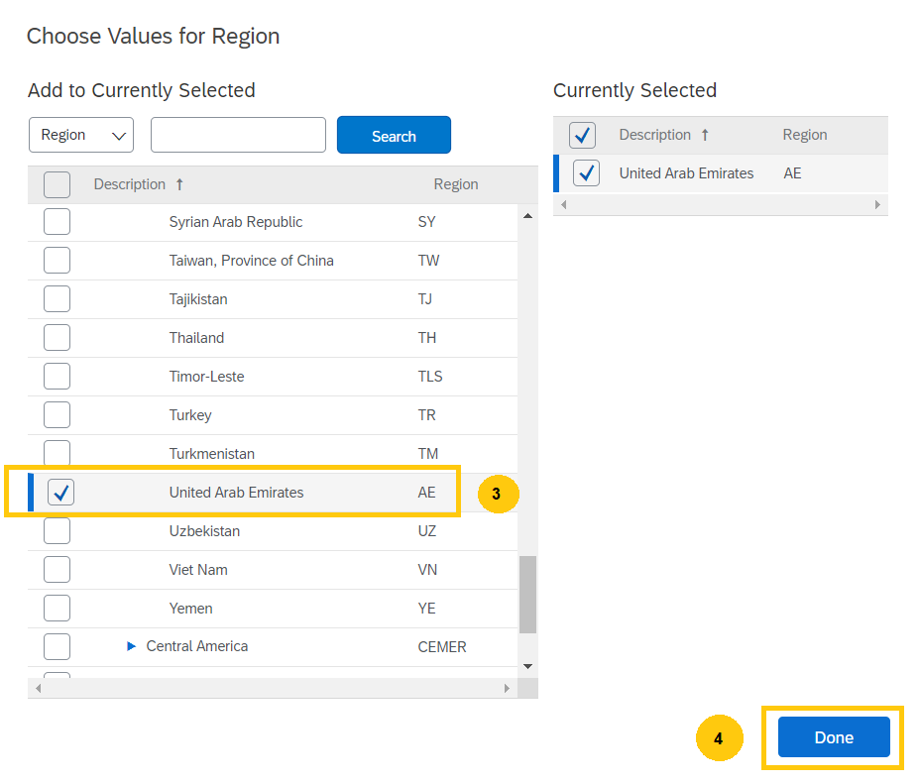

6. If you wish to provide **‘Intermediary Bank’** details, please select **‘Yes’** to question 6. System

opens another question like question 5 to add ‘Intermediary Bank’ details.

1. Click on **Submit Entire Response** button once completed.

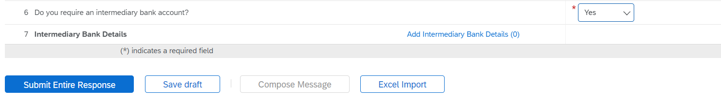

**6**

**7**

1. Click on **OK** from the pop-up window to submit your response.

**Note**: System allows ‘saving’ the questionnaire intermittently. It is a good practice to save the

questionnaire periodically when adding the details.

#### Reminders:



**8**

* + You have 181 days for General Registration Questionnaire and 180 days for Payment and Bank Questionnaire to complete and submit these questionnaires. If you fail to do so within the given timeframe, you must contact the GPO Supplier Registration team to request a new registration invite.
  + You can enter either a PO Box or Zip code in the Zip Code field.
  + If you wish to attach more than one document in a single field, compress or zip the documents then upload.

Once the “**General Registration Questionnaire**” and “**Payment and Bank Questionnaire**” are submitted, reviewed and approved, the contact person receives an email notification informing you that the Supplier Registration process is completed.

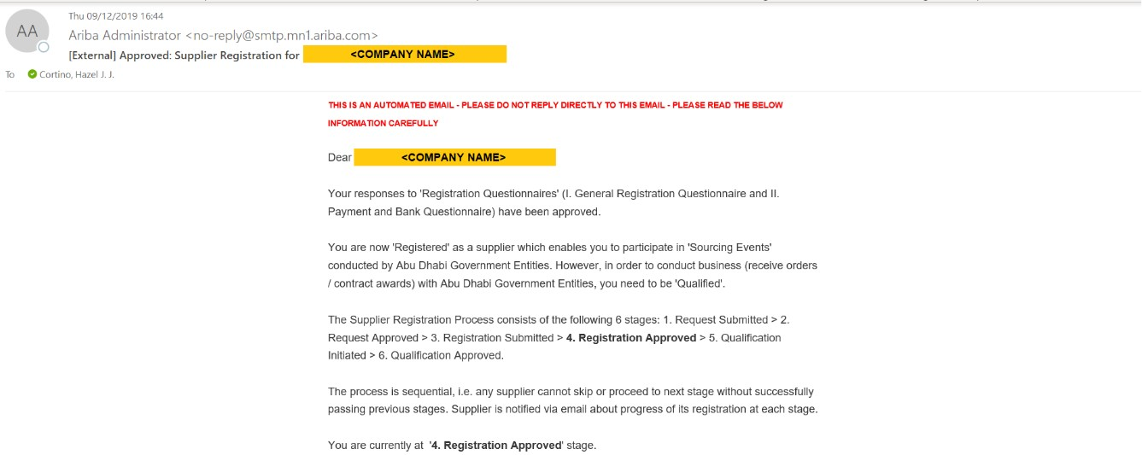

Registration Status can also be seen in the Registration Questionnaires section upon logging in to SAP Ariba Network Supplier Portal - <https://service.ariba.com/Sourcing.aw/>. Once Registered, the Registration Questionnaires are open indefinitely.

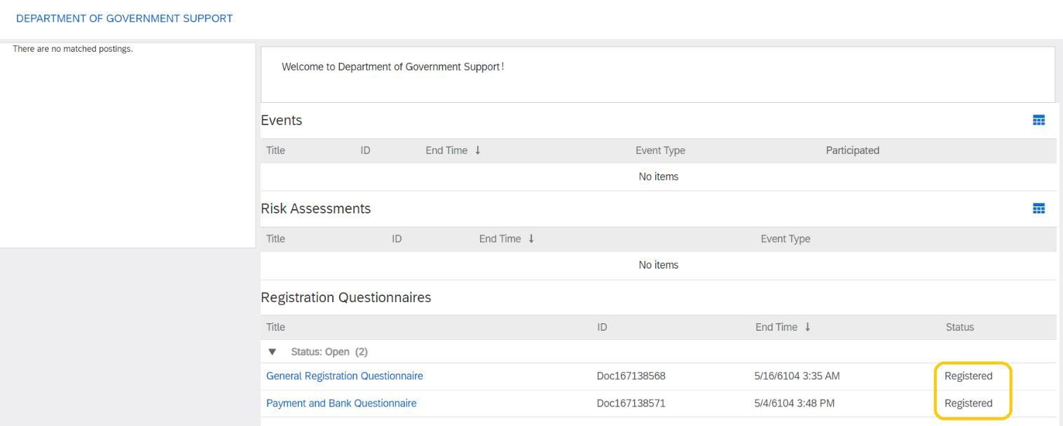

**STEP 3. Supplier Qualification**

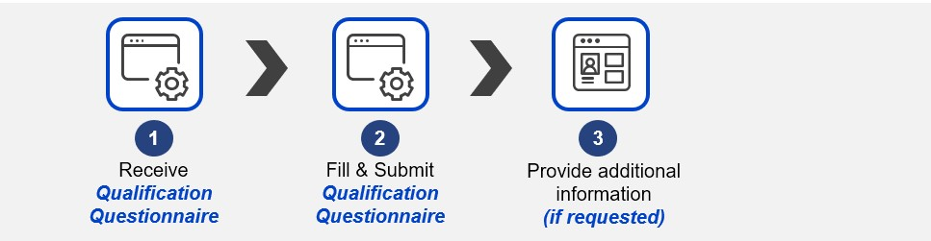

## STEP 3.1. Respond to the Supplier Qualification

After the registration is approved, business user initiates a qualification process. Supplier contact receives a notification to respond to the qualification questionnaire.

1. Click on **“**Click Here**”** in the email notification.

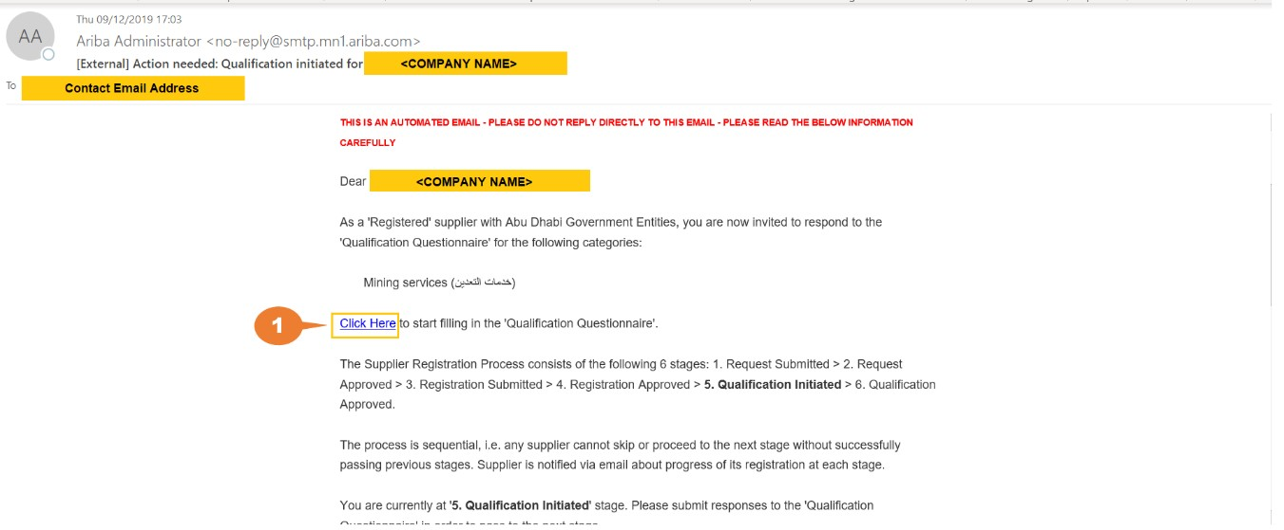

**1**

1. Input supplier credentials then click Login.

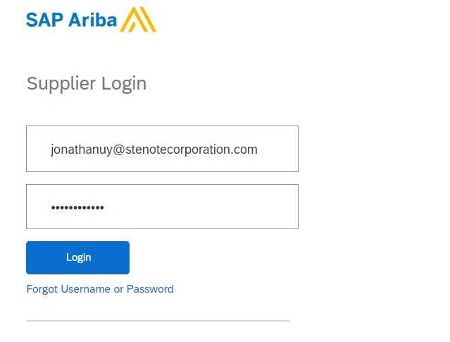

**2**

You are then redirected to the **Supplier Qualification Questionnaire** page.

1. Fill out all required questions.

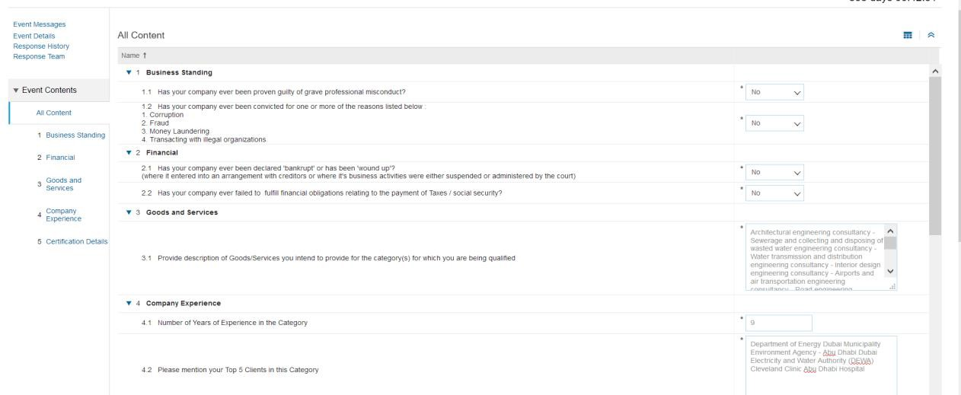

**3**

1. Once completed, click on “**Submit Entire Response**”.



**4**



**5**

Qualification status can also be seen in the Qualification Questionnaires section upon logging in to SAP Ariba Network Supplier Portal - <https://service.ariba.com/Sourcing.aw/>.

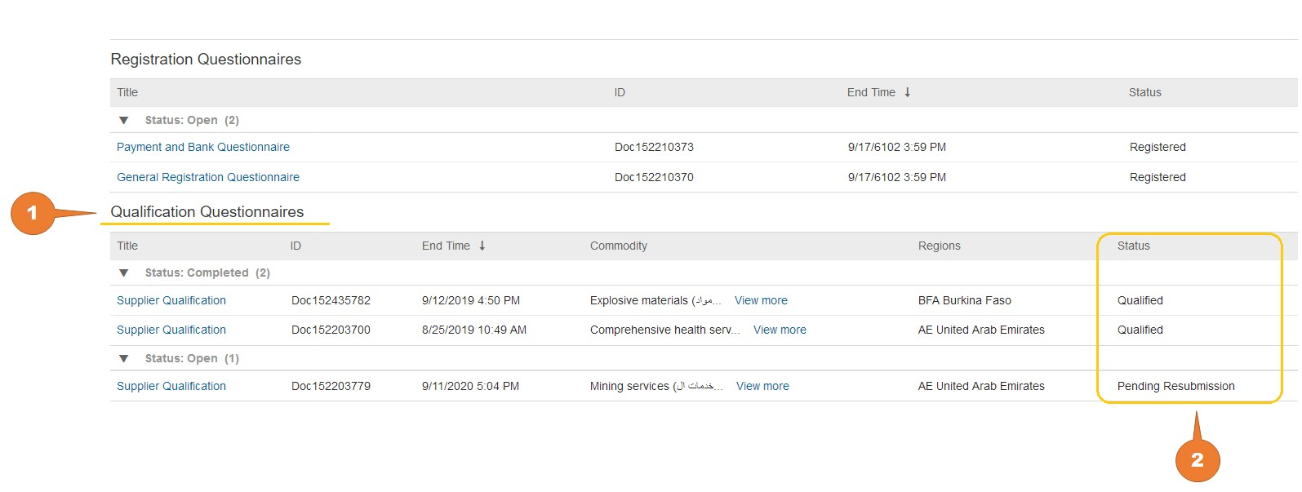

If status is Pending Resubmission as shown above, system sends a notification regarding the details to be updated. Kindly address these details and submit the questionnaire.

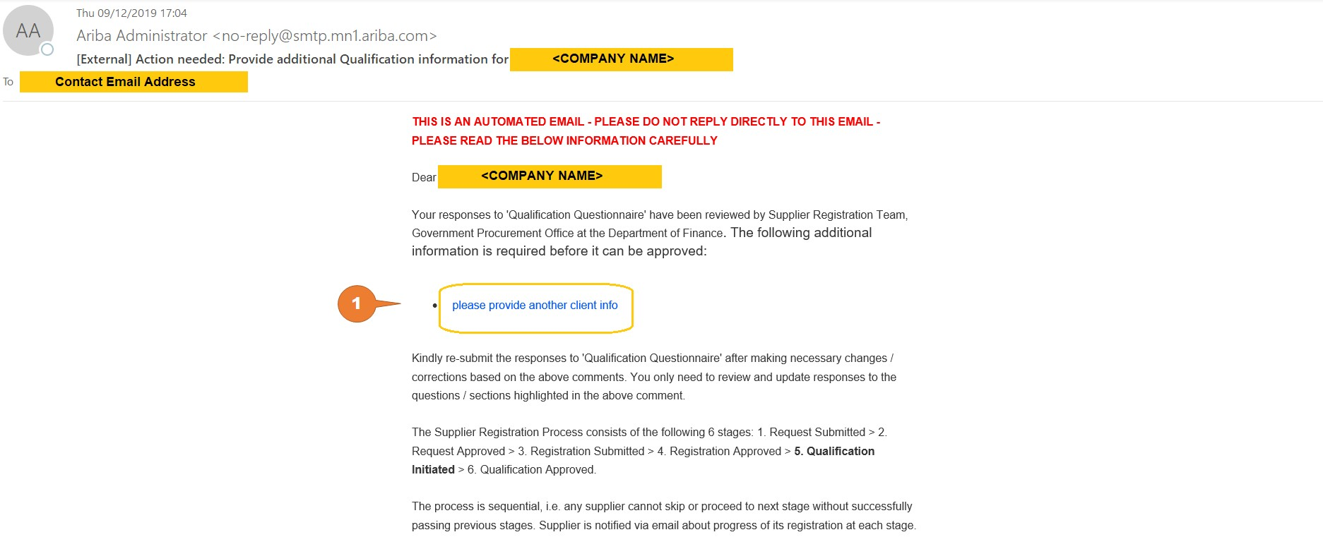

#### Reminders:

* + Suppliers have 30 days to complete the qualification questionnaire.

# REVISE/UPDATE SUPPLIER QUESTIONNAIRE RESPONSES

In some cases, you may need to revise or update your Supplier Questionnaire responses. You may also be asked to provide additional or supplementary information by the GPO Supplier Registration team. In such cases, follow the steps outlined below.

* Access Ariba Network site <<https://service.ariba.com/Sourcing.aw/>>
  1. Input supplier credentials then click **Login**.



**1**

* 1. Click on the Registration Questionnaire in which the response to be revised is located.

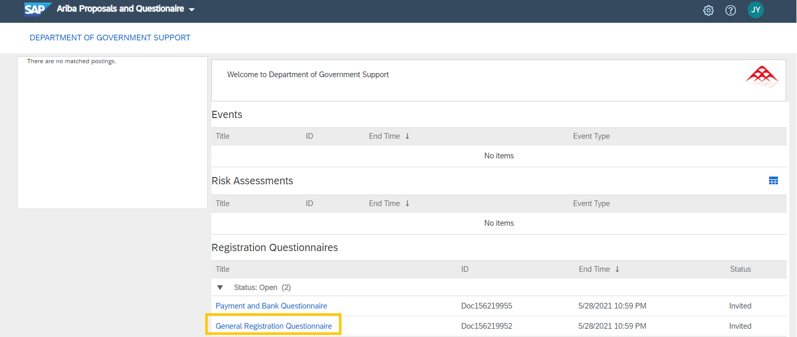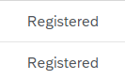

**2**

* 1. Click **“Revise Response”.**

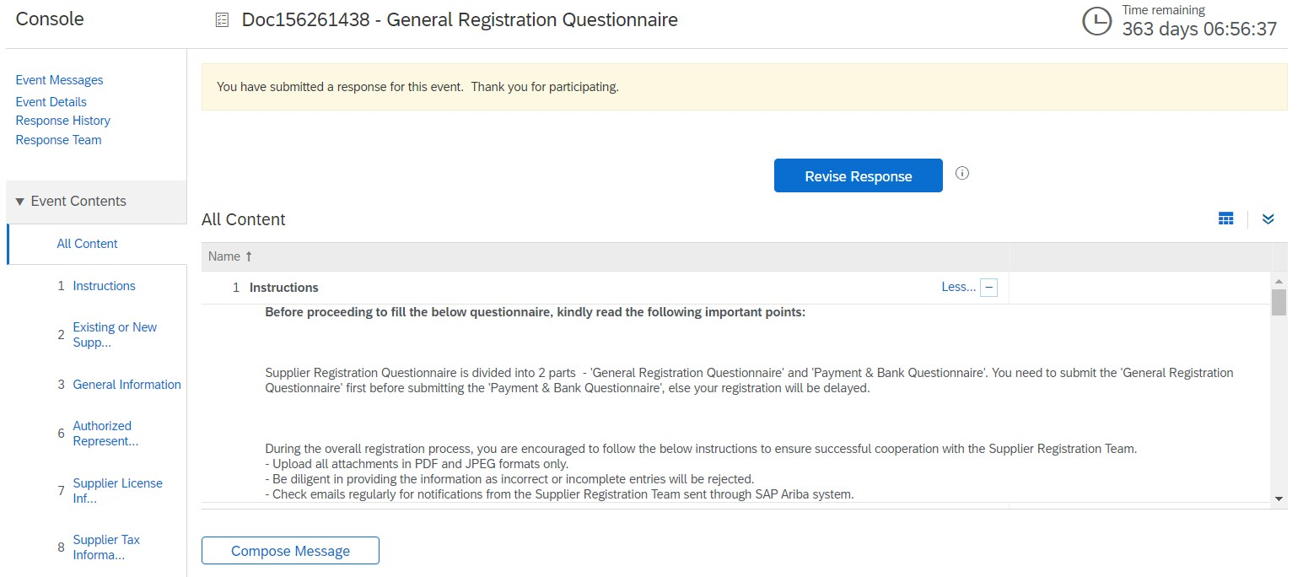

**3**

* 1. ` Click “**OK**” on the pop-up window.

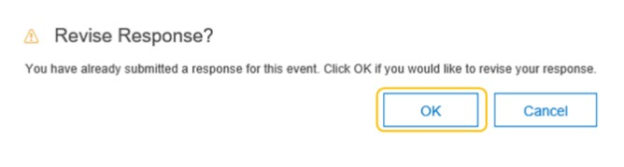

**4**

* 1. Revise/update the necessary information. Once all revisions are made, click **“Submit Entire Response”.**

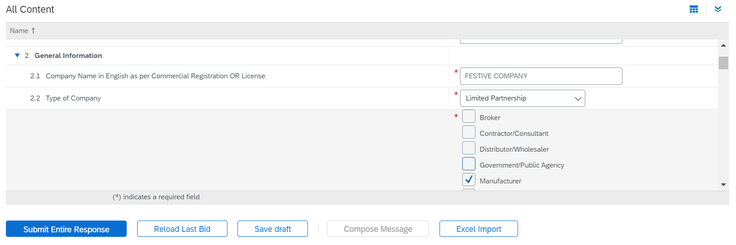

|  |  |
| --- | --- |
| **5** | |
|  |  |
|  |



**6**

#### A confirmation message will appear stating that the revised response has been submitted.

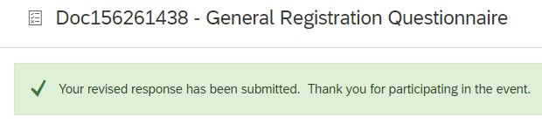

Once the revised Supplier Registration Questionnaire response is submitted, it undergoes another review and approval. A system-generated email is sent to notify you that the registration process is complete.

# PROVIDING ADDITIONAL INFORMATION TO GPO SUPPLIER REGISTRATION TEAM

Should Supplier Registration team require additional information, you will be notified via a system- generated email.

* 1. Follow the **“Click Here”** link in the email.

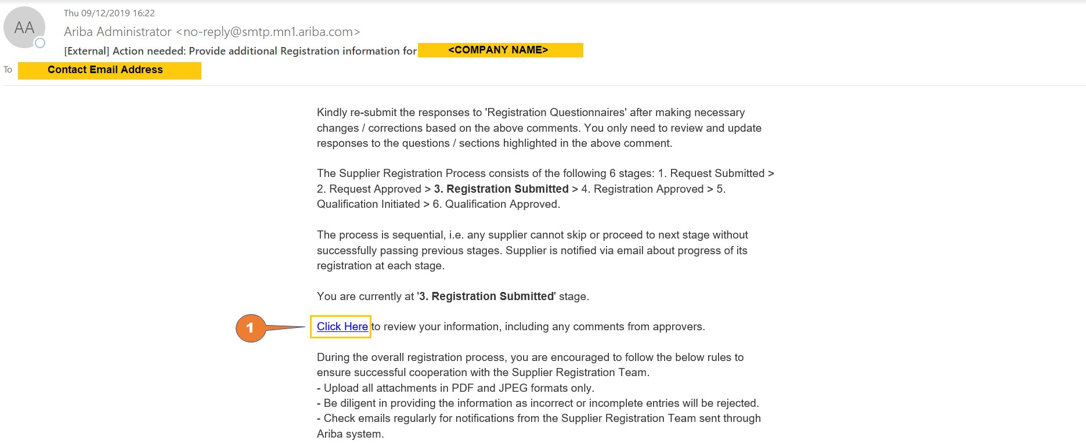

**1**

You will be directed to the Registration Questionnaire in which the approver requested for additional info.

* 1. Click **“Revise Response”.**

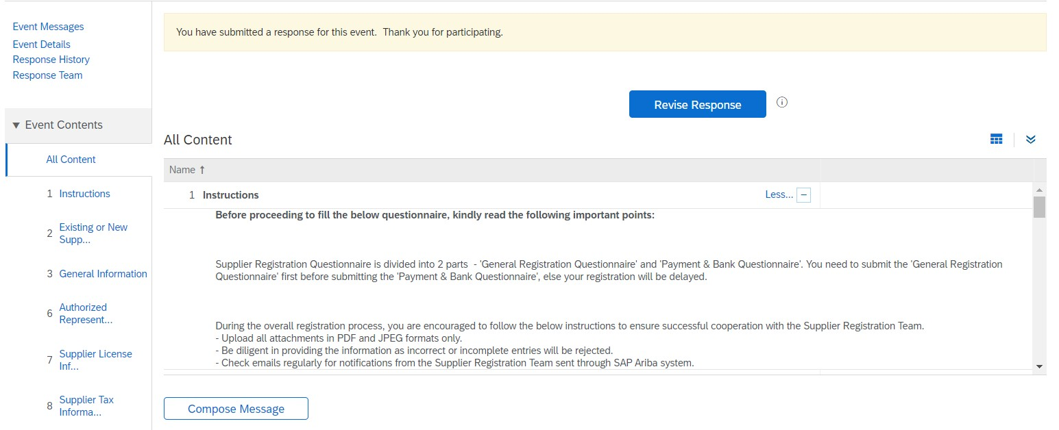

**2**

* 1. Click “**OK**” from the pop-up window.



**3**

* 1. You may also check the comment from Supplier Registration Team.
  2. Update the information specified in the comment from Supplier Registration team.
  3. Once all revisions are made, click “**Submit Entire Response”.**

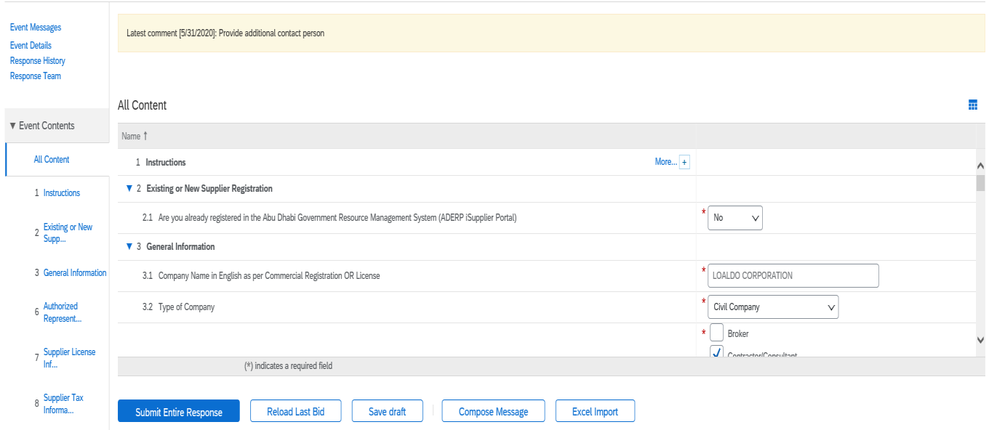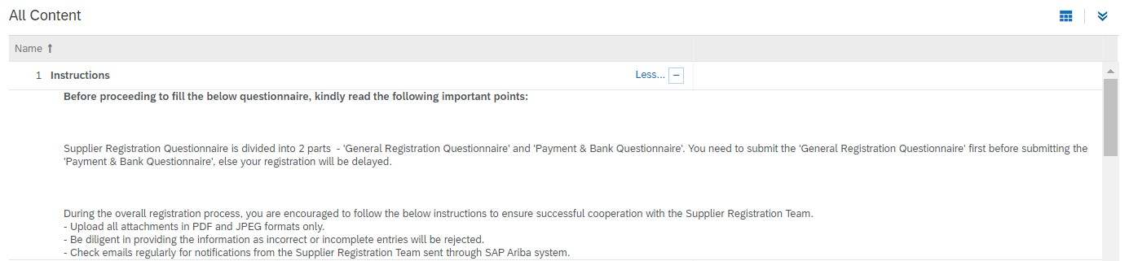

|  |  |  |
| --- | --- | --- |
| **4**  **5** | | |
| **6** |  |  |

7. Click **OK** from the pop-up window to submit your response.



**7**

# REQUIRED DOCUMENTS TO COMPLETE SUPPLIER REQUEST AND SUPPLIER REGISTRATION

## Suppliers with Non-Abu Dhabi DED License

## Supplier Request

N/A

## Supplier Registration

* + - Valid tax registration and/or business license and/or commercial certificate
    - Copy of Articles of Association / Partnership Agreement
    - Authorization Letter on Company Letterhead for the Person Authorized to provide Supplier Information for Registration
    - Bank confirmation account letter issued from the bank

# SAP ARIBA HELP CENTER – HOW TO RAISE A TICKET TO SAP ARIBA NETWORK SUPPORT

* 1. Enter supplier credentials then click **Login**.



**1**

* 1. On the top right side, click on **“?“** icon.

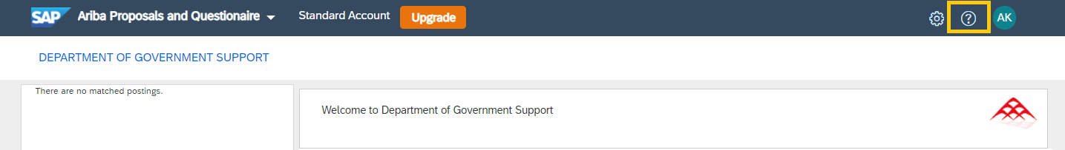

**2**

* 1. Click on **Support**.

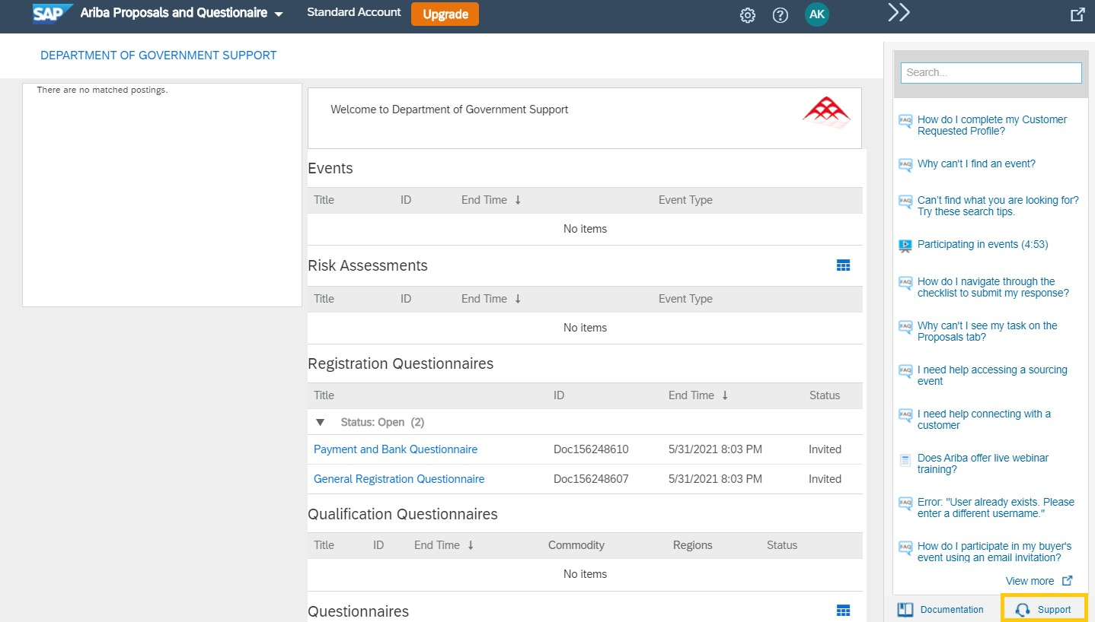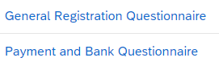

**3**

* 1. Write what you need help within the search box.
  2. Click “**Start**”.

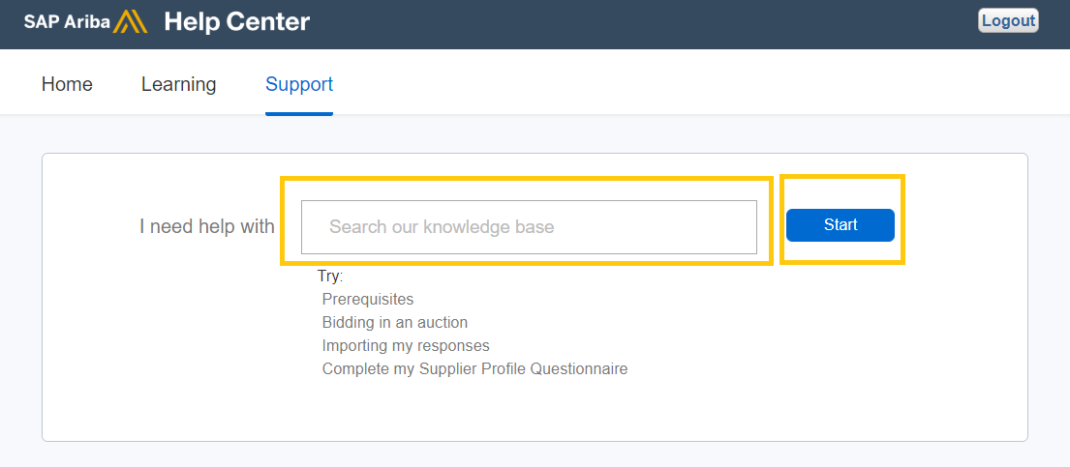

**4**

**5**

If you can’t find what you are looking for, you can get help by email.

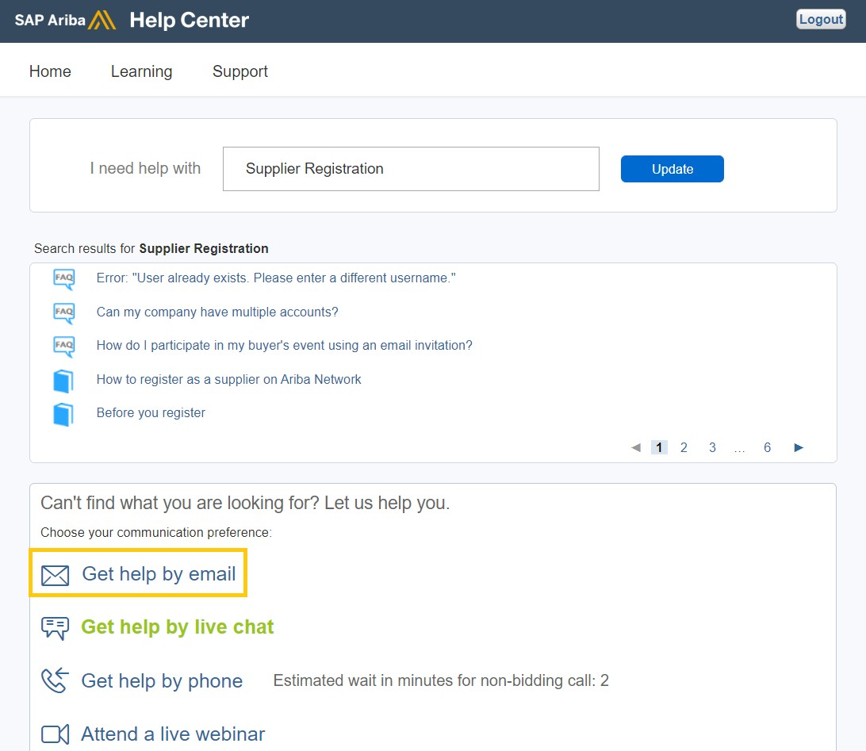

If you chose to get help by email, you need to fill in all mandatory fields marked as “*” in below

form then press submit. You will receive an email shortly to assist you with your issue.

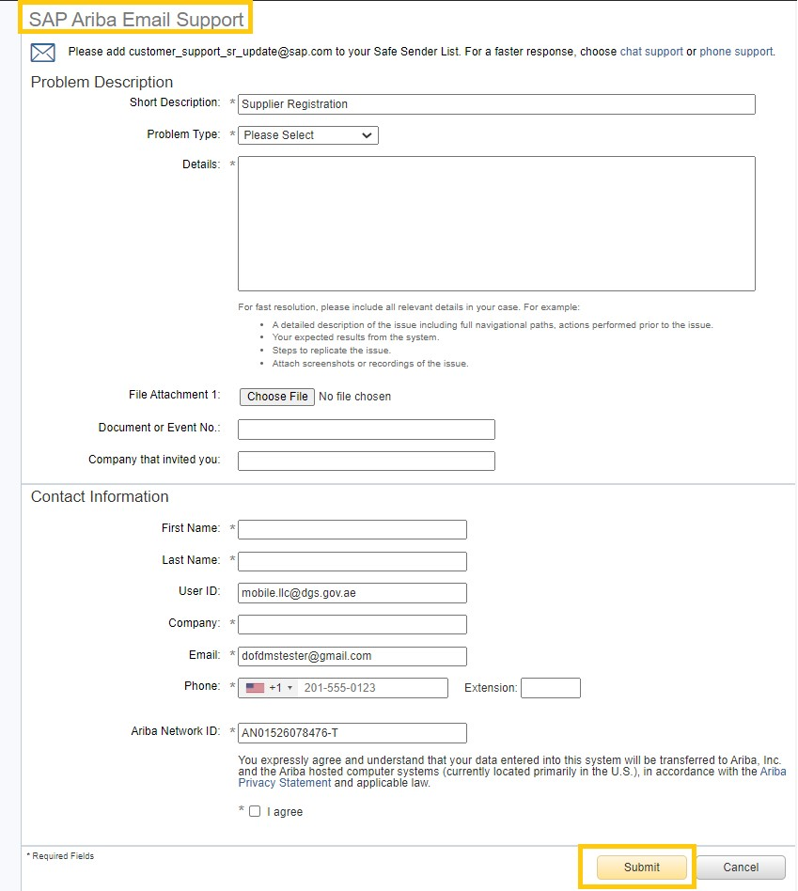

**6**

# FREQUENTLY ASKED QUESTIONS (FAQS)

#### How do I know the status of my Supplier Request?

You will see a confirmation page once the request is submitted to Abu Dhabi Government. You will also receive an email notification that the request has been sent to Abu Dhabi Government.

#### What happens next after I submit my Supplier Request?

Your request goes to Abu Dhabi Government supplier registration team for approval. Once the team approves your request, you will receive an email notification asking you to register on SAP Ariba Network.

#### Is it mandatory to open an SAP Ariba Network account for registering as a supplier with Abu Dhabi Government?

Yes, you can only access your registration questionnaires after creating an account in SAP Ariba

Network. SAP Ariba Network is the new portal for suppliers.

#### Who will receive the email after my Supplier Request is approved?

The contact person's email that was entered in the supplier request form will receive the email for registration. This user is the primary contact for the supplier registration.

#### Why am I not receiving email notifications from SAP Ariba?

If you are not receiving the emails from SAP Ariba, reasons could be (1) the email address that you provided in the supplier request is incorrect; (2) email notification settings are not configured properly; or (3) your company’s email server is blocking the emails from external sources.

To resolve these issues:

For issue 1, please raise a new supplier request [here](http://dofad.supplier.mn1.ariba.com/ad/selfRegistration).

For issue 2, please see [How do I change or update my email address or username?](https://support.ariba.com/item/view/146034) or [How do I](https://support.ariba.com/item/view/106475)  [update my email notification preferences?.](https://support.ariba.com/item/view/106475) If you are able to confirm that the email address is correct and your notifications are configured properly, contact your local IT department to resolve the issue related to your email server not allowing the emails to reach your inbox.

For issue 3, your IT team will have to whitelist the addresses below to ensure that the emails from SAP Ariba is not being blocked – @smtp.mn1.ariba.com and @ansmtp.ariba.com. Until SAP Ariba domains are whitelisted in your organization, you will not be able to receive the notifications and will cause delay in the registration.

#### What if the contact person who raised the Supplier Request is no longer working for my company?

In this case, you must contact DGS supplier registration team to resend the registration invitation to

the new contact person. The new contact will then receive the email for registration.

#### I already have an SAP Ariba Network account used for my other clients. Can I use the same account for Abu Dhabi Government?

Yes, you can login with your existing SAP Ariba Network account. However, if you have an existing

'FULL' Ariba Network account with your other client, please immediately inquire with SAP Ariba if there would be an additional subscription fees on using the same account for Abu Dhabi Government. DGS, however, recommends you to have a new Ariba Network account for Abu Dhabi Government.

#### Is there a timeline to submit the Supplier Registration Questionnaires?

The registration has two questionnaires that you need to complete – “General Registration

Questionnaire” and “Payment and Bank Details”. You must submit both these questionnaires within

180 days after Supplier Request is approved.

#### What if I missed to submit the Supplier Registration Questionnaires within 180 days?

In case you have missed the 180 days window, please contact the DGS Supplier Registration team to resend the questionnaires.

#### How do I know the status of my registration?

Once all questionnaires are submitted, GPO Supplier Registration team and Government Accounts team will review and approve your questionnaires’ responses. You can see the status in the “Registration Questionnaires” section when you log into Ariba Network. You will also receive an email once your registration is approved.

#### Can I change my details in the Supplier Registration Questionnaire?

Yes, you can change the details. However, please note that every change is subject for approval.

#### I received a request for qualification from GPO Supplier Registration team. What is the qualification process?

Qualification process is the next stage after registration. In the qualification stage, the DGS

Supplier Registration team verifies the supplier's experience in the categories they have registered for.

#### How do I know if my company is qualified or not for a certain category?

You will receive an email from GPO Supplier Registration team confirming if you are qualified or not for that certain category.

* 1. **How can I update the contact person’s email address on my SAP Ariba Network Account?** Login to the SAP Ariba Network portal <https://service.ariba.com/Sourcing.aw/>. Click on the account name located in the upper right corner → My Account. Change the Email Address in the Account Information section. Confirm by clicking on the link in the email sent to the new email address.

#### What do I do if the Revise Response button does not appear?

If supplier has submitted their responses for review and approval, Revise Response button is disabled to allow the respective team to review the changes made. During this time, supplier won’t be able to perform any further updates. Once review is completed and Registration team has completed processing the update request, supplier may again update the questionnaires as necessary. If urgent update needs to be done, contact helpdesk hotline immediately.

* 1. **I have completed the registration process but received a notification requesting for me to update certain questions in the Registration Questionnaires. How should I proceed?** Department of Government Support has system changes on the questionnaires which requires for

the suppliers to re-enter some of the responses that were removed from these changes. Kindly

update the required information as necessary for us to have the latest information of the suppliers.

**CONTACT US**

In case of any queries / clarification in the supplier registration process, contact the Supplier Registration Team for assistance **Email:** [srs@dgs.gov.ae](mailto:srs@dgs.gov.ae)

